|  |  |  |  |  |  |
| --- | --- | --- | --- | --- | --- |
| **Module No:** | 6 | **IU No:** | 3 | **Exercise No.** | 3 |

**Name : Agung Yuda Pratama  
Code : BDSE-0922-076/STTB**

|  |  |
| --- | --- |
| **Lab Assessment Statement** | **Assignment 3 - Build a simple site**  **Referring to Assignment-1's Project Scenario,**  The scope of this assignment is to develop a simple site with rich content creation like a real-world web application development. Initially, our "Online News Portal" site is a blank place so we need to create content and dynamic functionality in pages.  In this assignment, you can free to develop whatever content you like, and are free to determine the layout that you believe will work best for the page.  This is a sample of what the final result should look like. The coloring can differ based on the theme you select.  HOME PAGE  NEWS PAGE  CONTACT US PAGE  ABOUT US PAGE  These are the steps provided to build a site. Some step provides the screenshot to get the desired result.   1. Firstly, Use Liferay's WCM feature to create web content.  * Create three content for news. * Use documents and Media features to upload news photo. * Create two contents for "About us" and "Contact Us". * For About Us and Contact Us page, add the necessary HTML to implement the layout.      1. Create two blog posts with embed videos by using blog Feature.      1. Create new “Application Display Template - ADT” developed with *Velocity* or *Free Marker Template* and enable it for changing the blog posts display dynamically.      1. Create "Page Template" with "Web Content" portlet.      1. Apply Page Template in About us and Contact us Pages.      1. Adding an application portlet into Home, News, About Us and Contact Us pages. 2. Update your "welcome" and other portlet design via from Look and Feel tab.   **Provide caption and screenshots for each step.**  **Provide screen capture of final result pages.** |
| **Technical Environment** | - |
| **Guidelines** | - |
| **Duration** | 120 mins |

These are the steps provided to build a site. Some step provides the screenshot to get the desired result.

1. Firstly, Use Liferay's WCM feature to create web content.

* Create three content for news.

Go to Content and Data, choose the Web Content and click Structure and click plus button

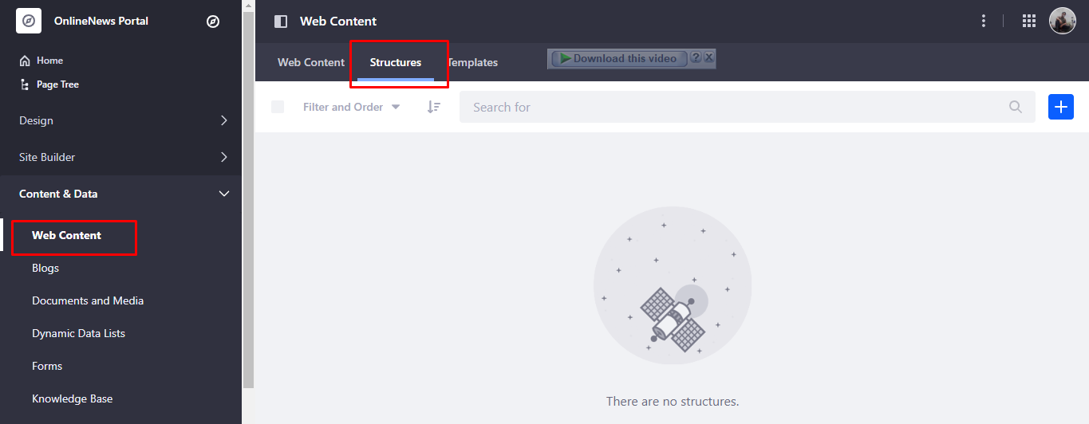  
**First Content**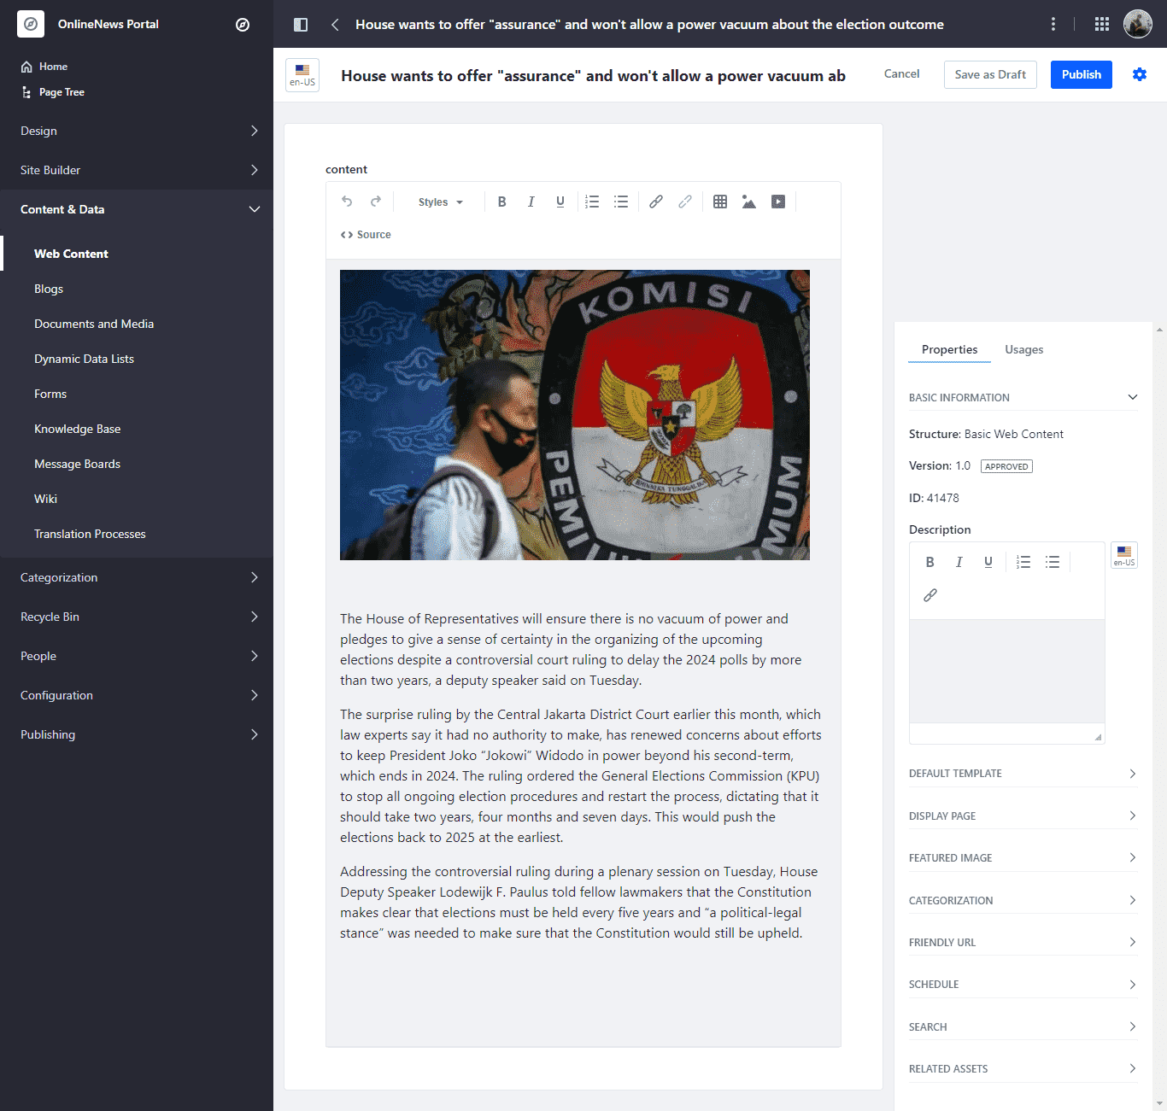

**Second Content**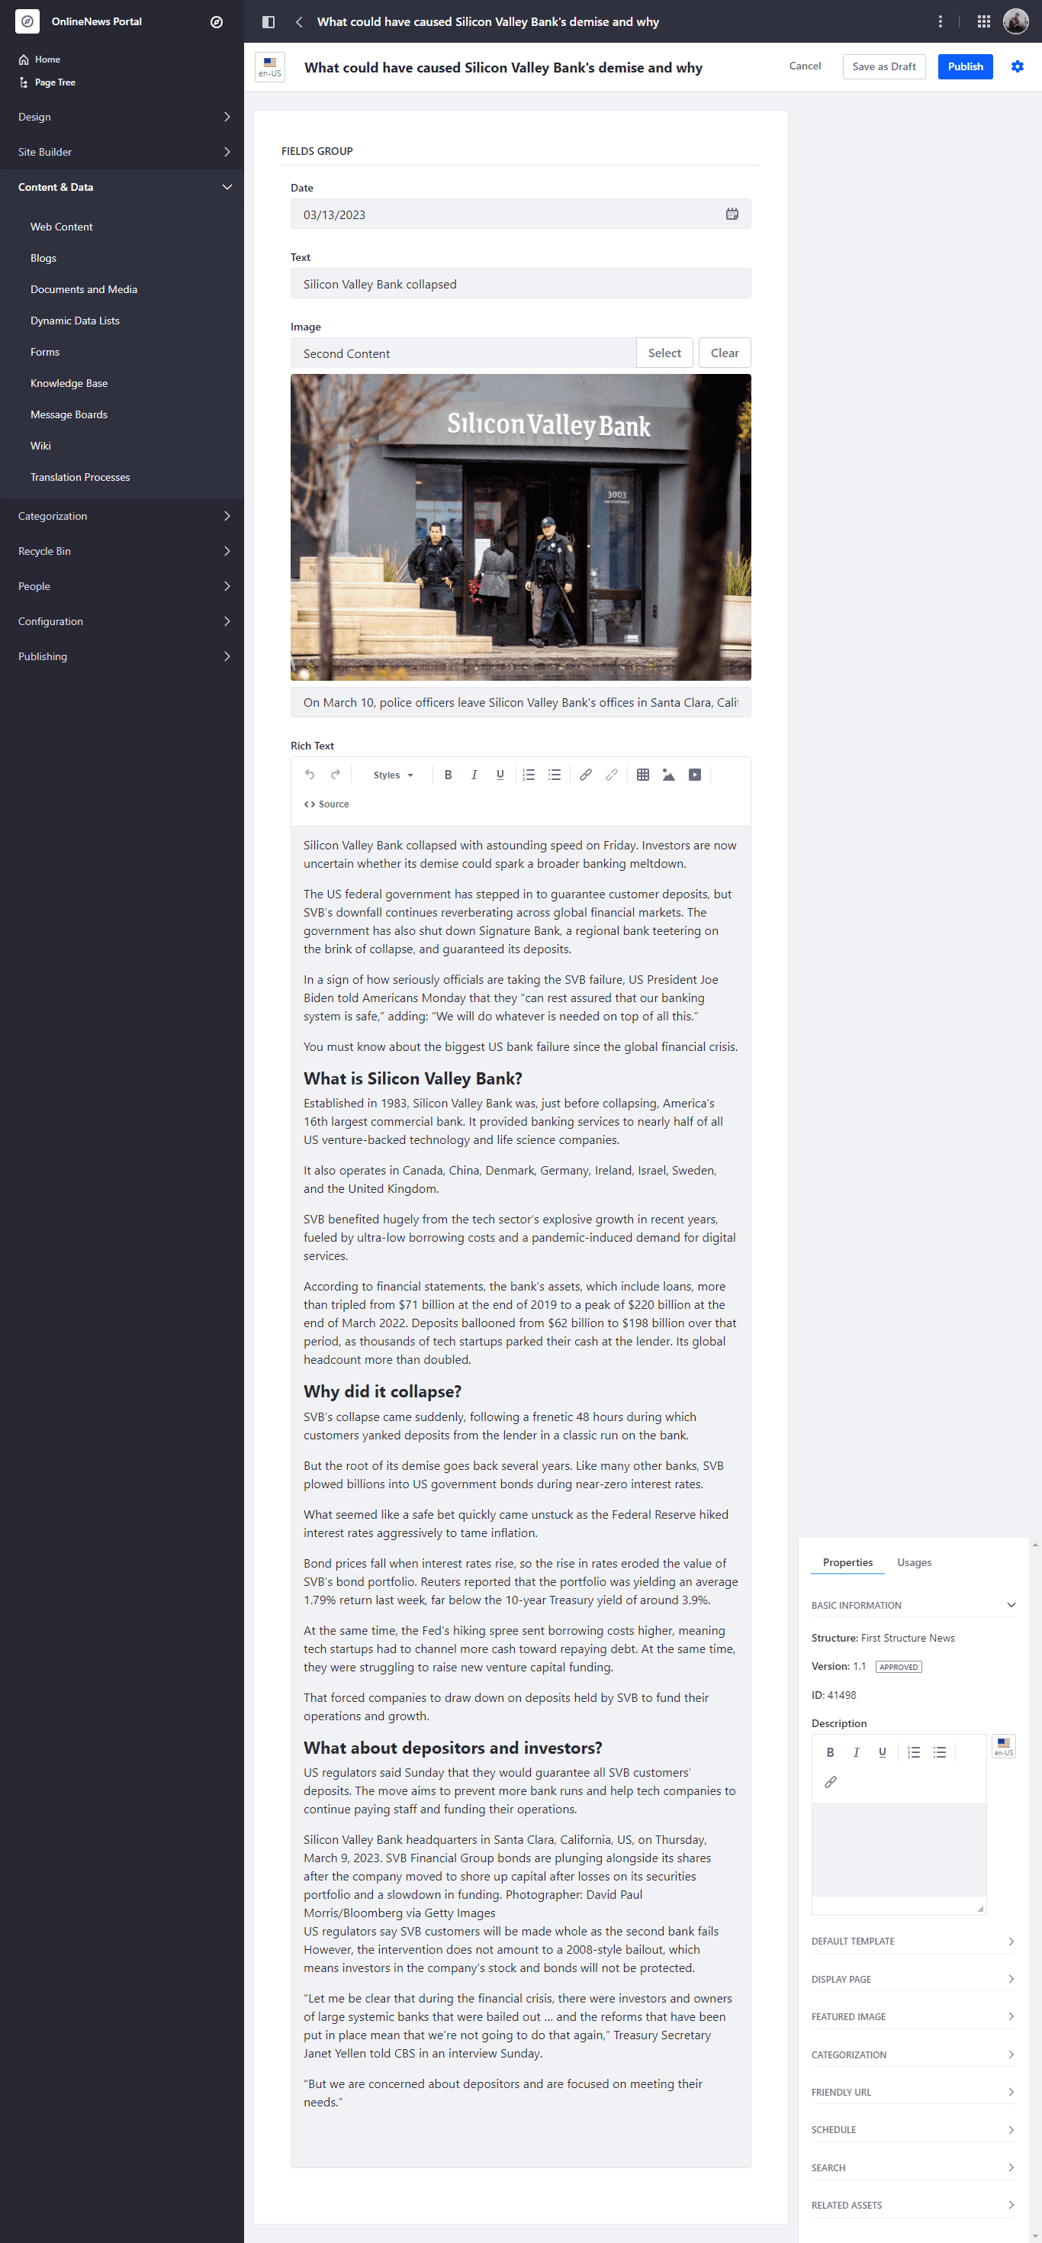

**Third Content**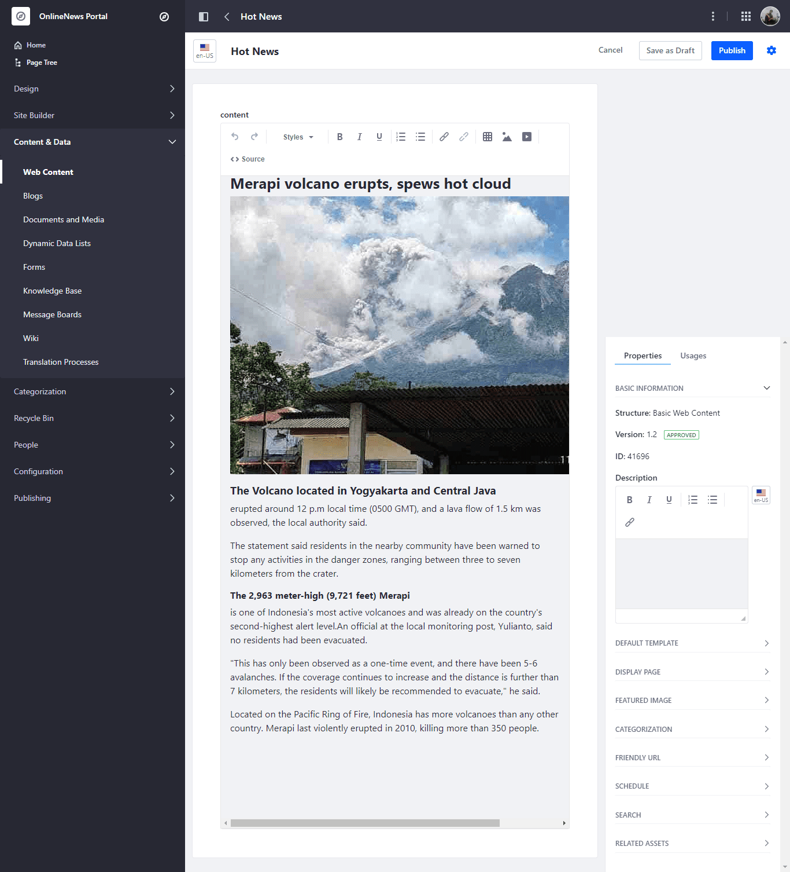

* Use documents and Media features to upload news photo. And click plus button to upload the media  
  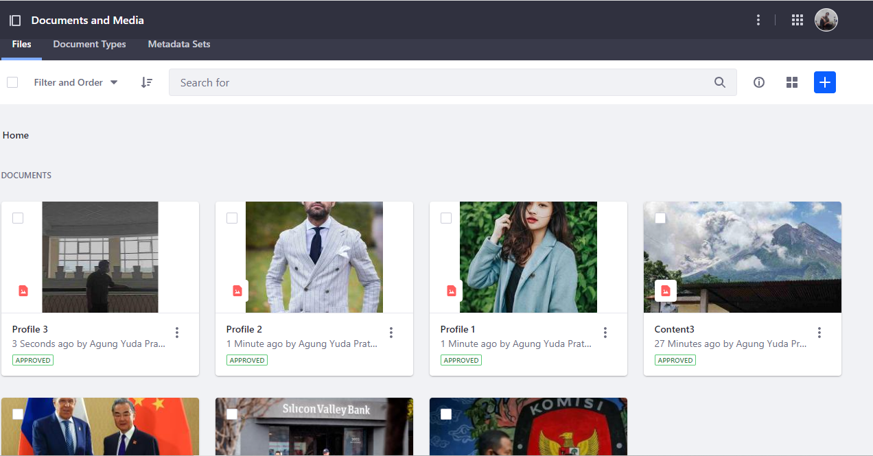
* Create two contents for "About us" and "Contact Us".

Because the page is Already, we just start to add some content

**About Us**  
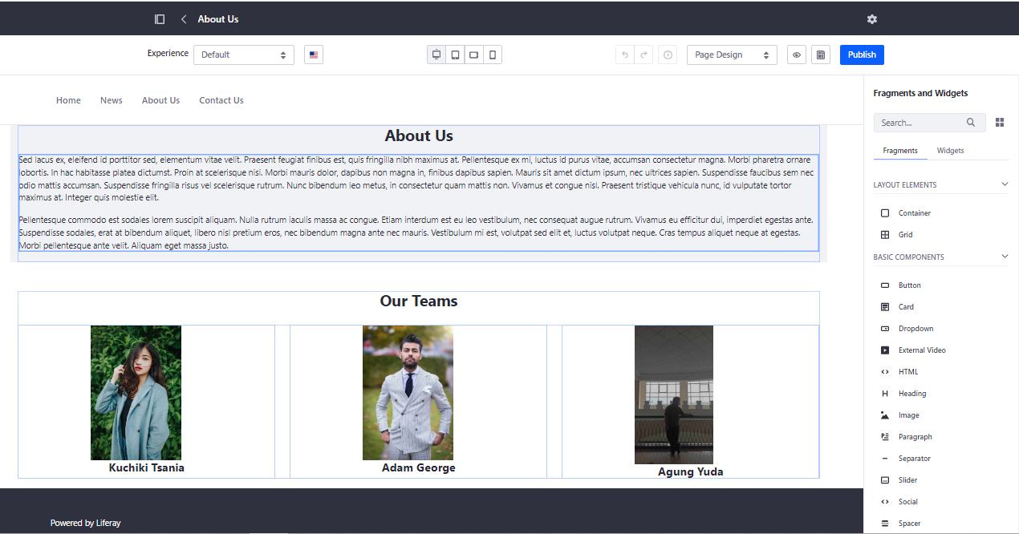

**Contact Us**

For adding maps into that, open maps and choose the location, after that you select the share button and copy the html

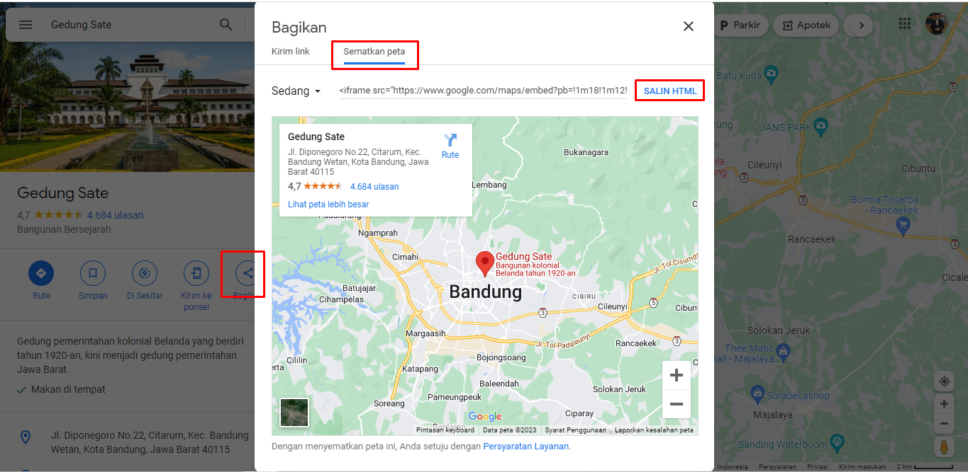

you can add HTML into container and double click on HTML

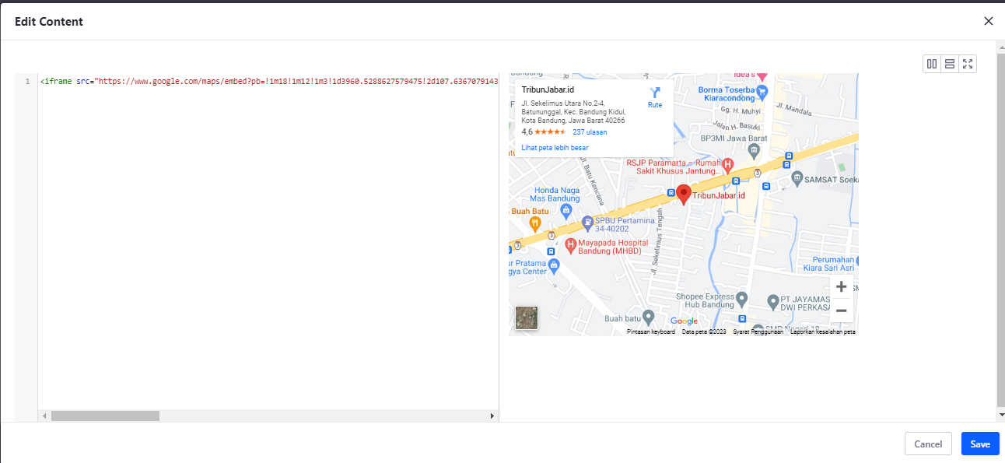

And be like this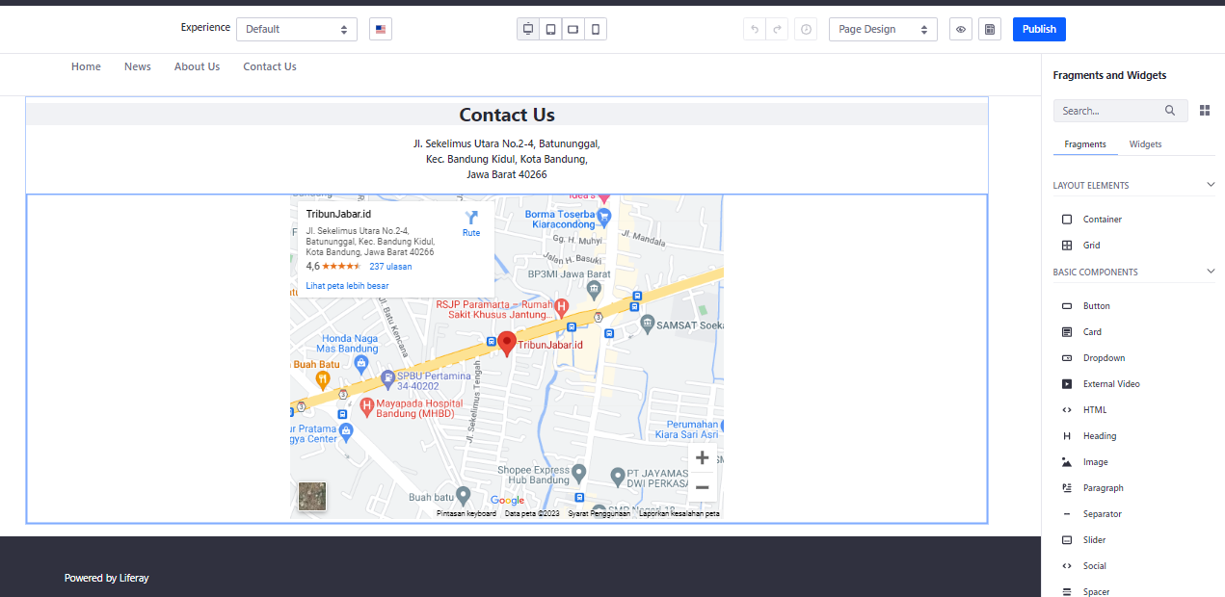

1. Create two blog posts with embed videos by using blog Feature.

Go to Content and data Click the blog, after showing the blog click plus button

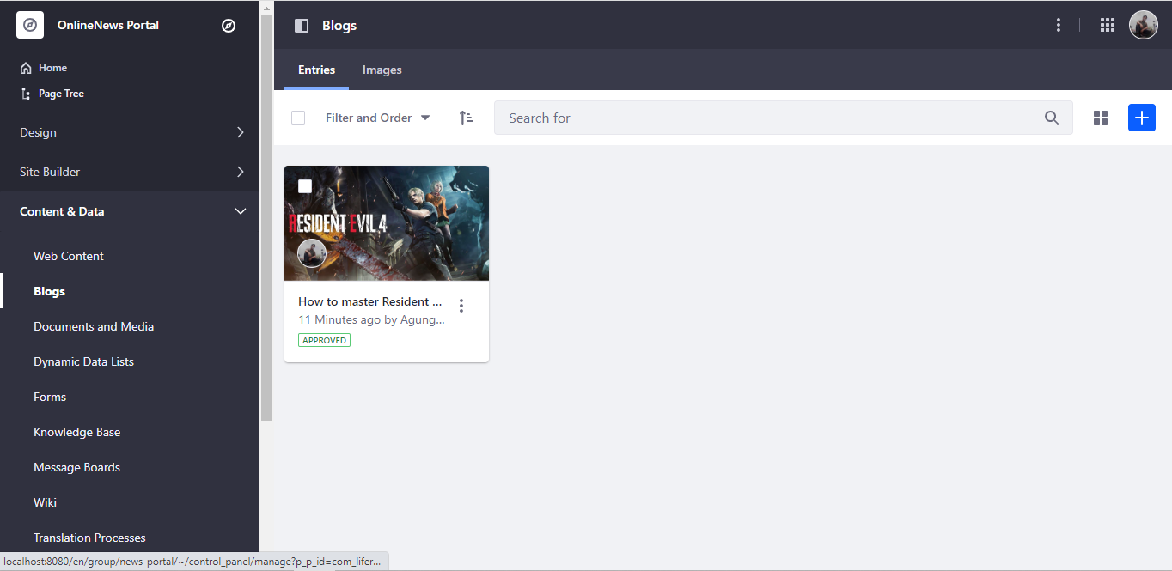

And you can fulfill what you want to add in this blog

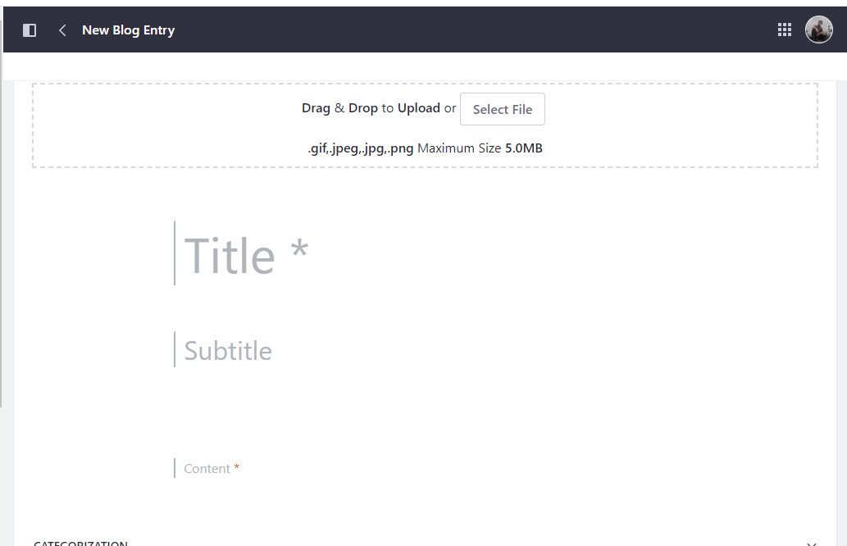

You can add video right here just click related assets and select

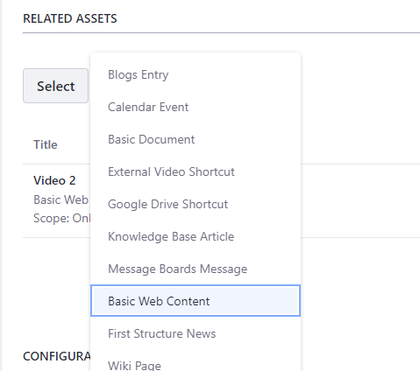

Choose the video you want to add on your blog

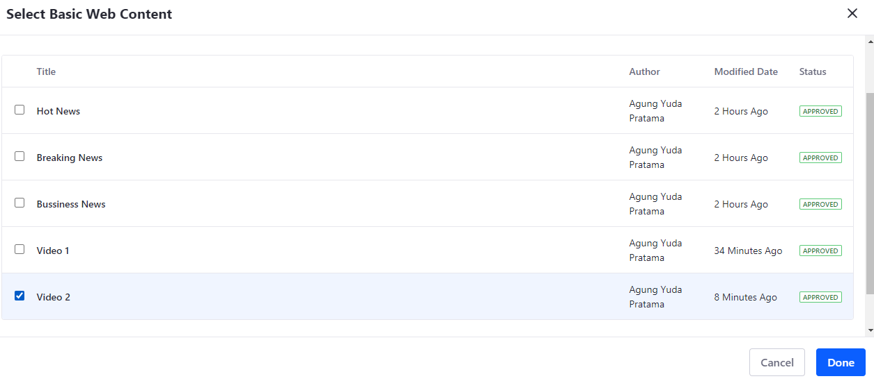

**After you fulfill the blog it should be like this and click publish button**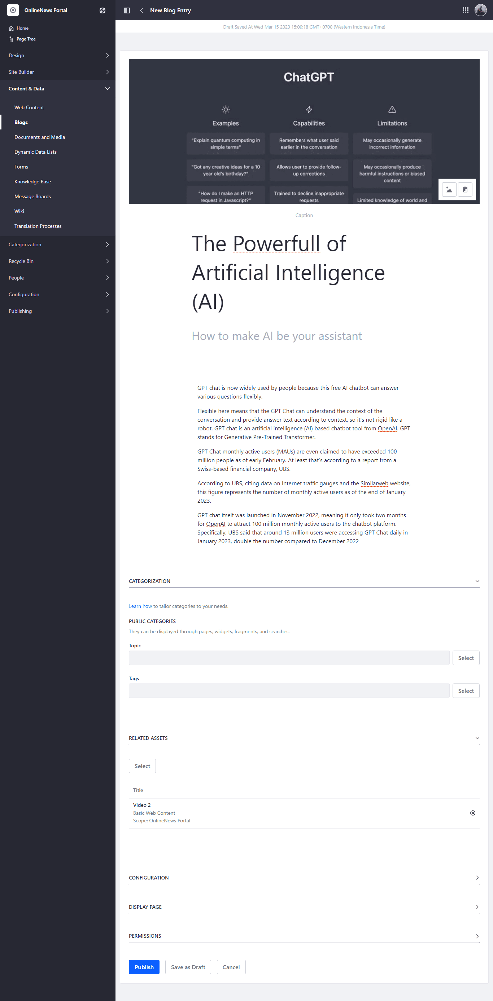

**Now you can see there is a blog you have made**

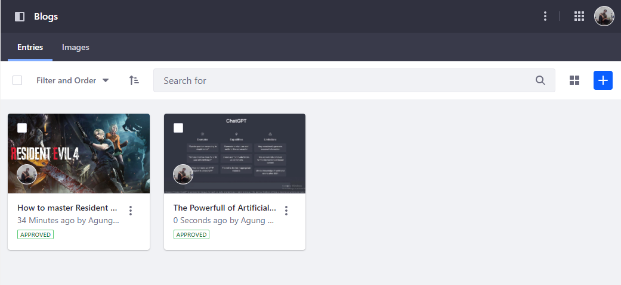

**First Blog**  


**Second Blog**  
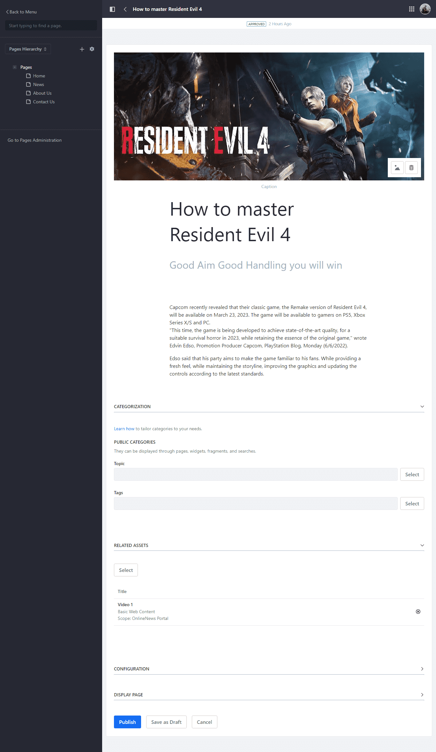

1. Create new “Application Display Template - ADT” developed with *Velocity* or *Free Marker Template* and enable it for changing the blog posts display dynamically.

Go to design > template > widget templates and choose blogs template

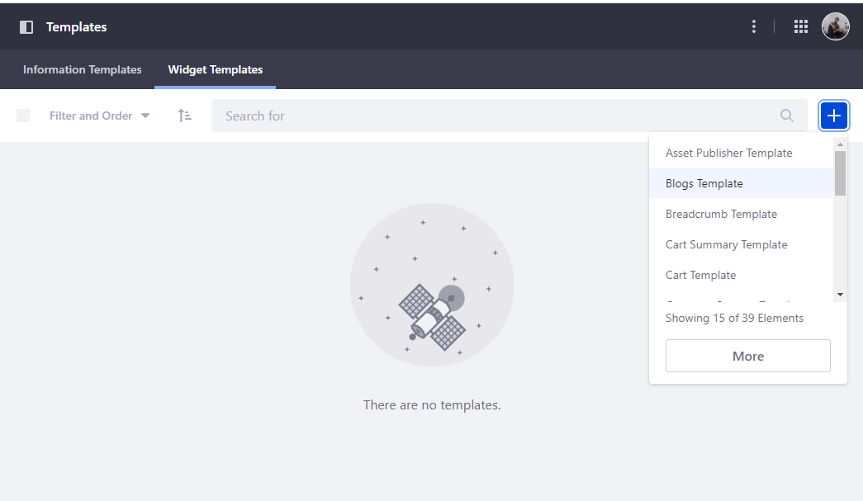

Add new template and choose blog on right panel

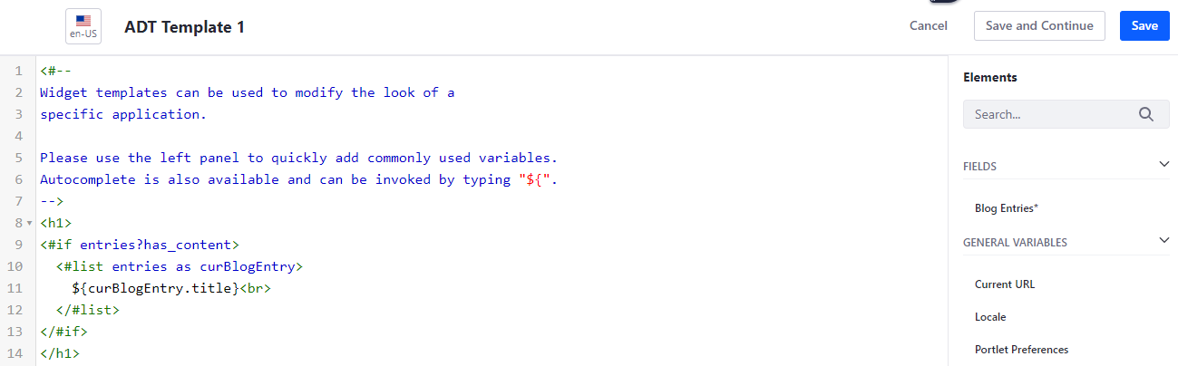

And now you can see the ADT

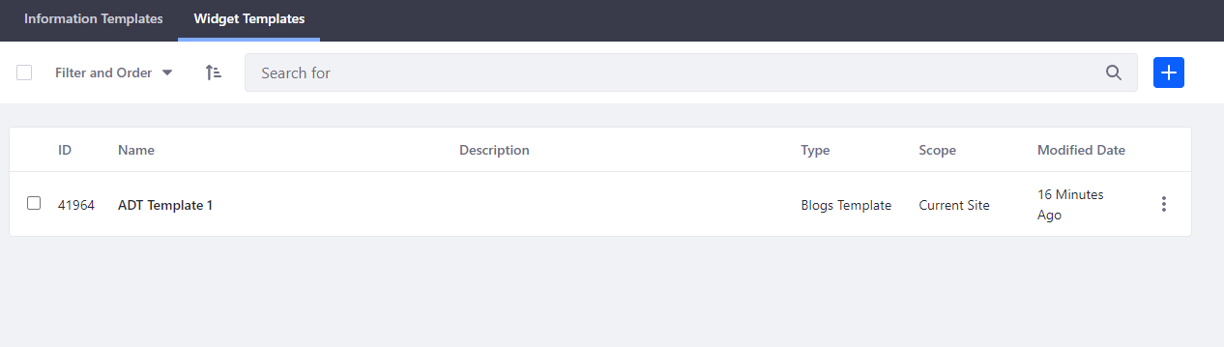

Go to home and select the blog part, click configuration scroll down and choose ADT Template 1

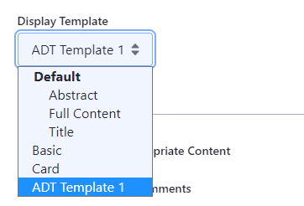

Here’s the result

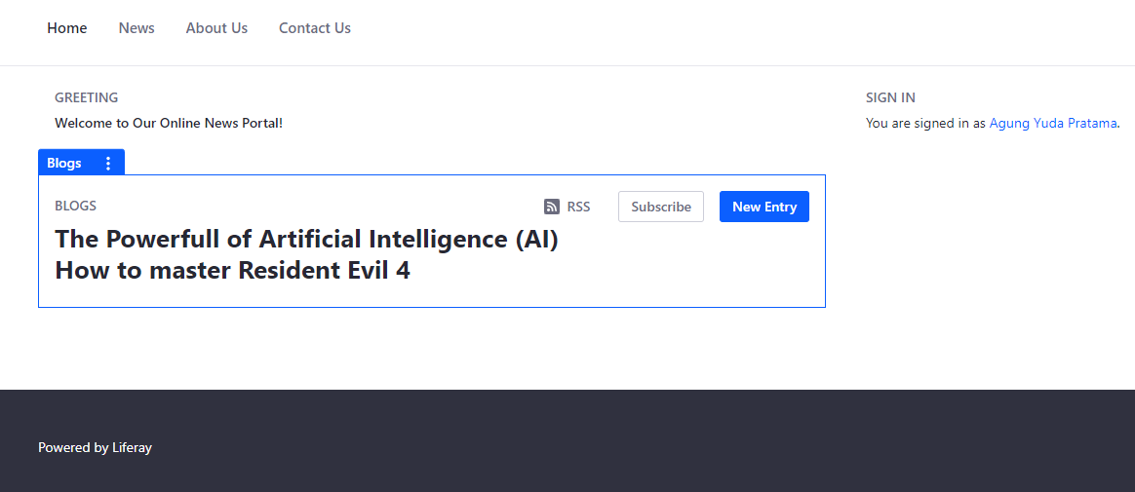

1. Create "Page Template" with "Web Content" portlet.

Go to menu, click design and choose the page template and click plus button

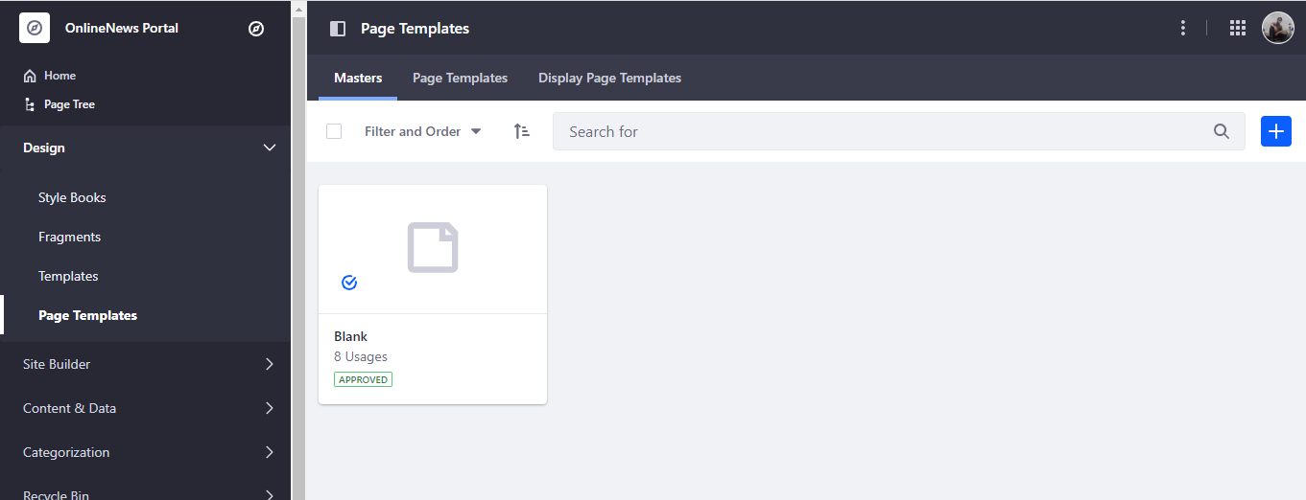

Now give the name and save

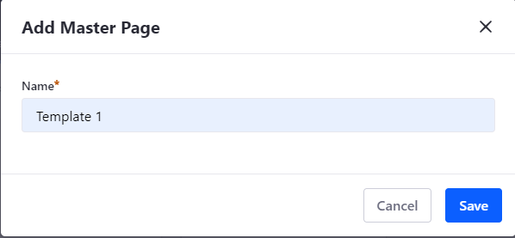

You can add with component that what you want after that click publish master

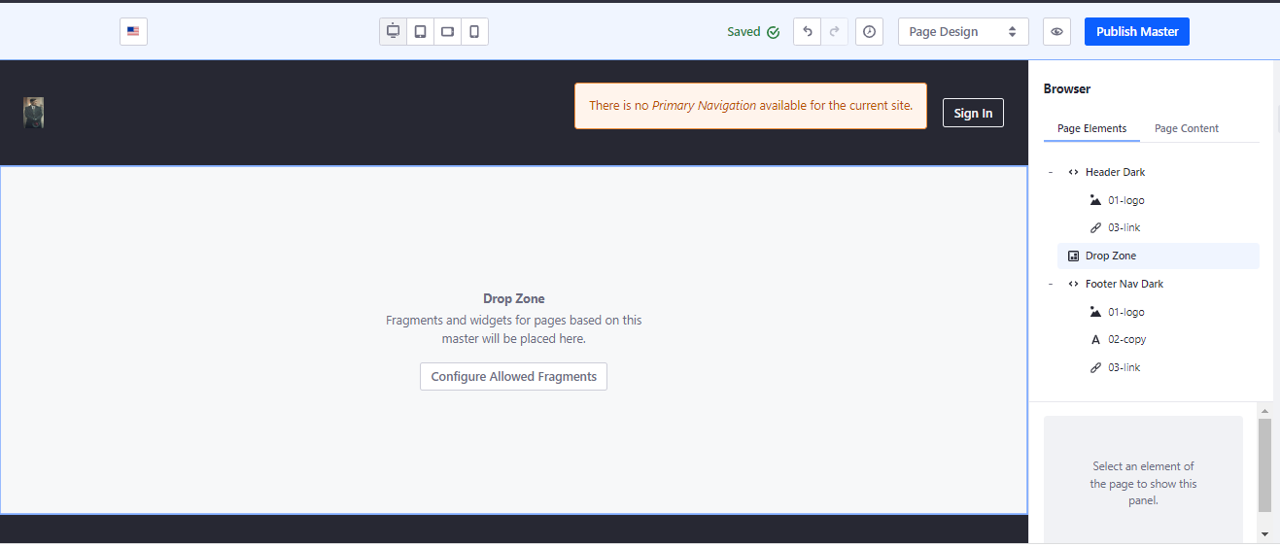

Now we can see the new templates for the website

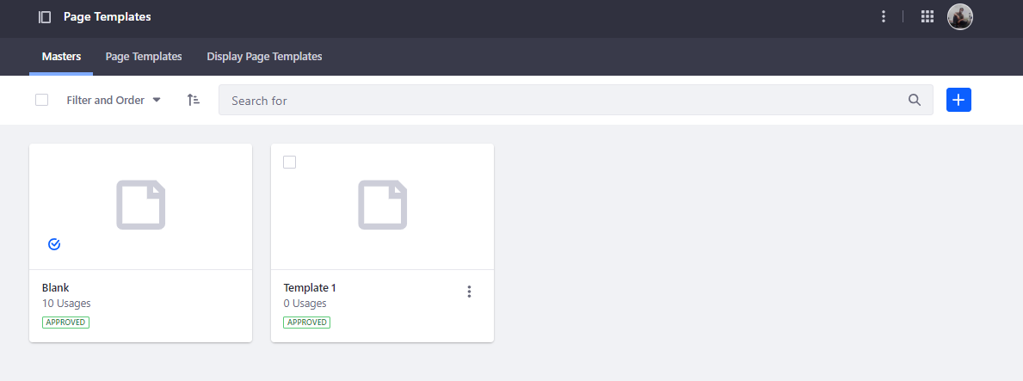

1. Apply Page Template in About us and Contact us Pages.

Now go to page tree and select About Us and Contact Us click on Edit and choose page design option

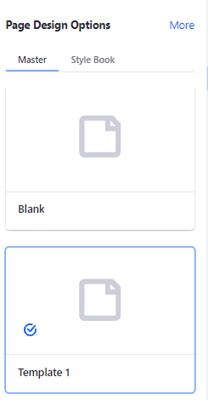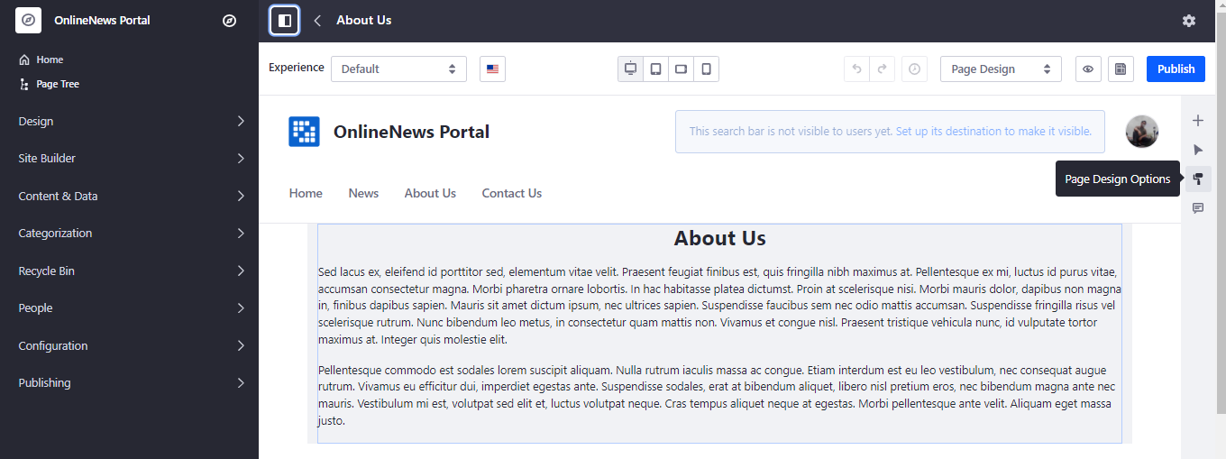

Click on Template 1 and publish

And you can see the template now

**About Us**

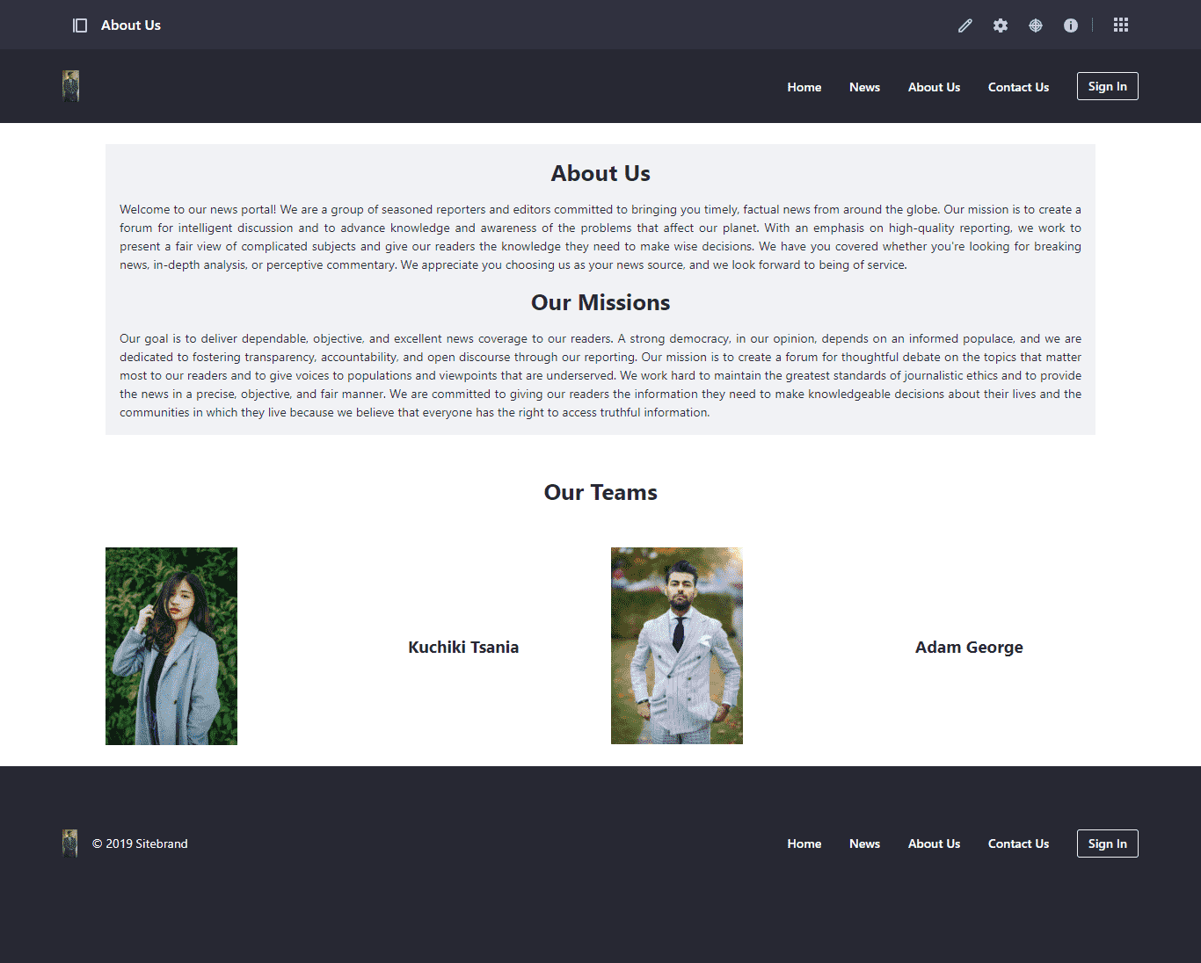

**Contact Us**

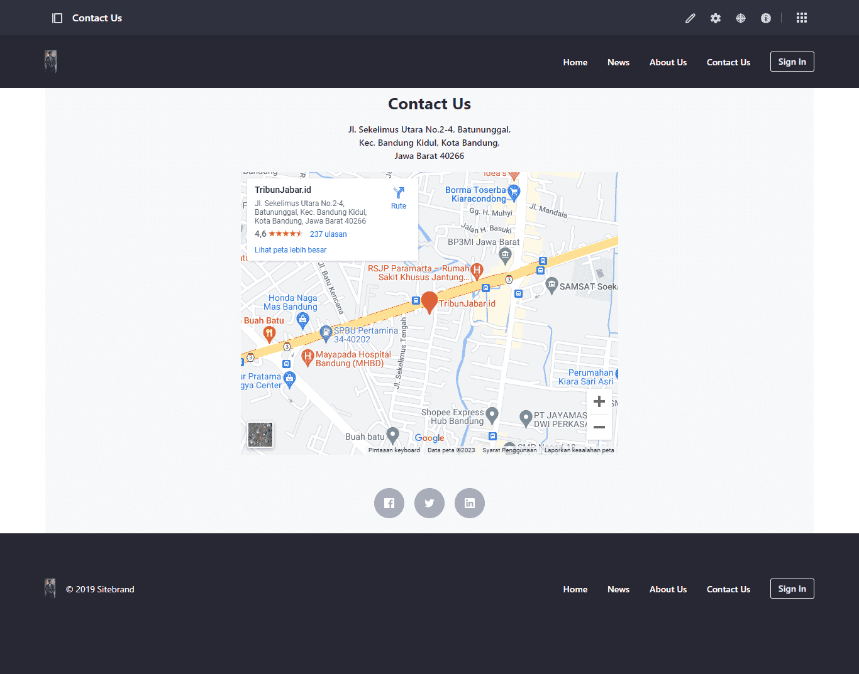

1. Adding an application portlet into Home, News, About Us and Contact Us pages.

**Home page with portlet**  
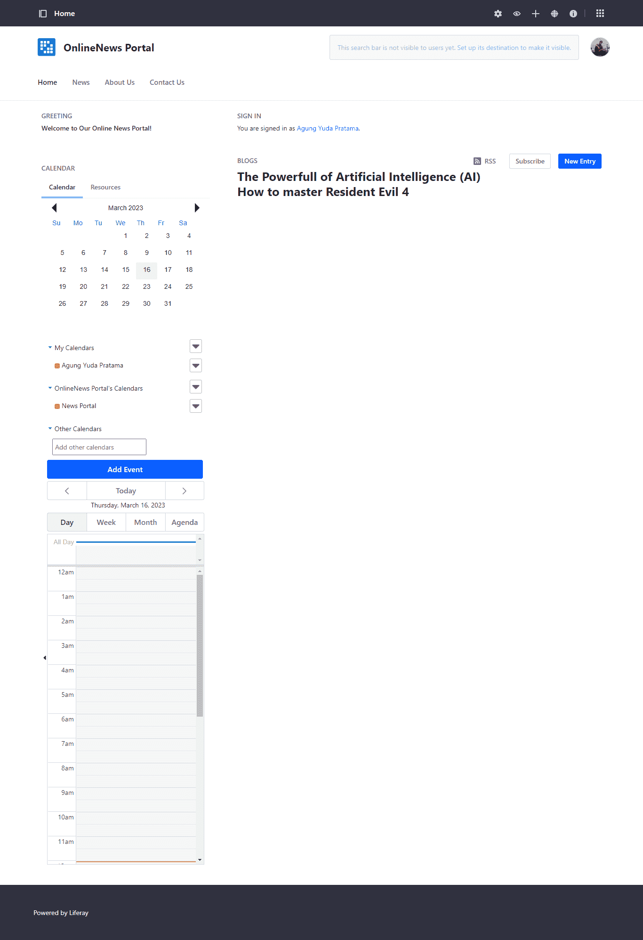

**News with portlet**  
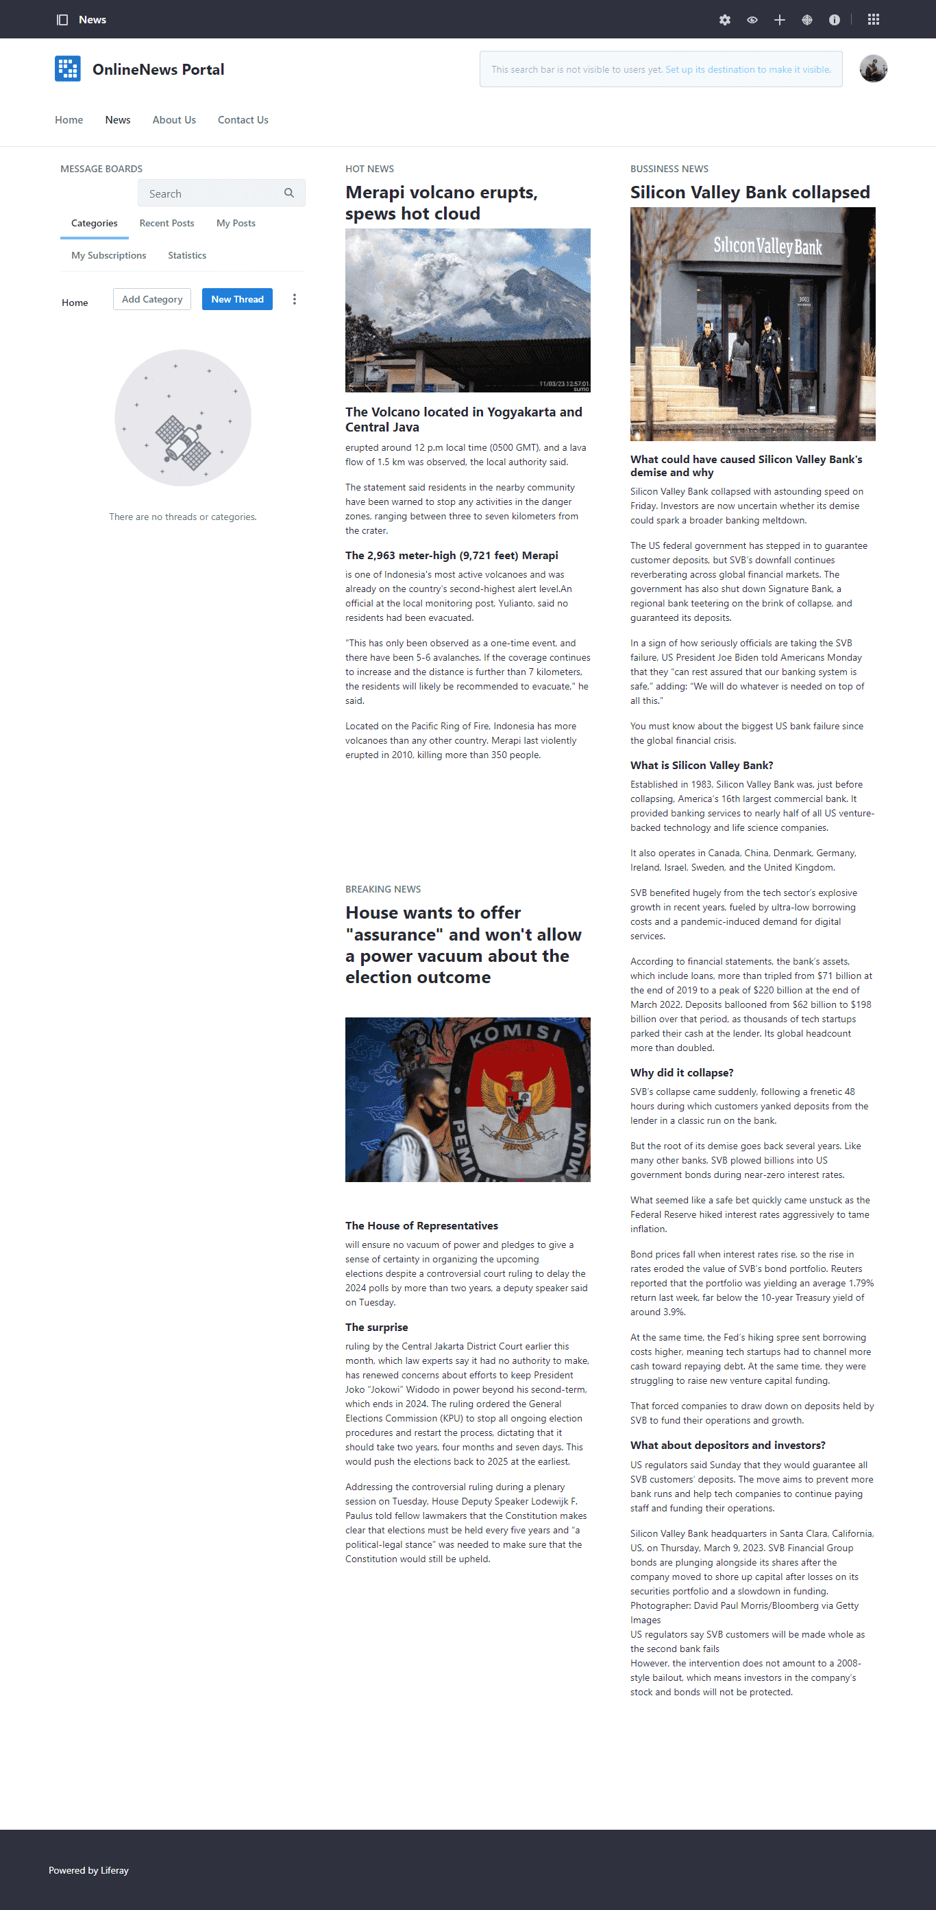

**About us with portlet**

**Contact us with portlet  
**

1. Update your "welcome" and other portlet design via from Look and Feel tab.

Go to your home and click the portlet and choose look and feel conf

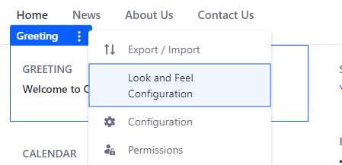

You can configure it whatever you like

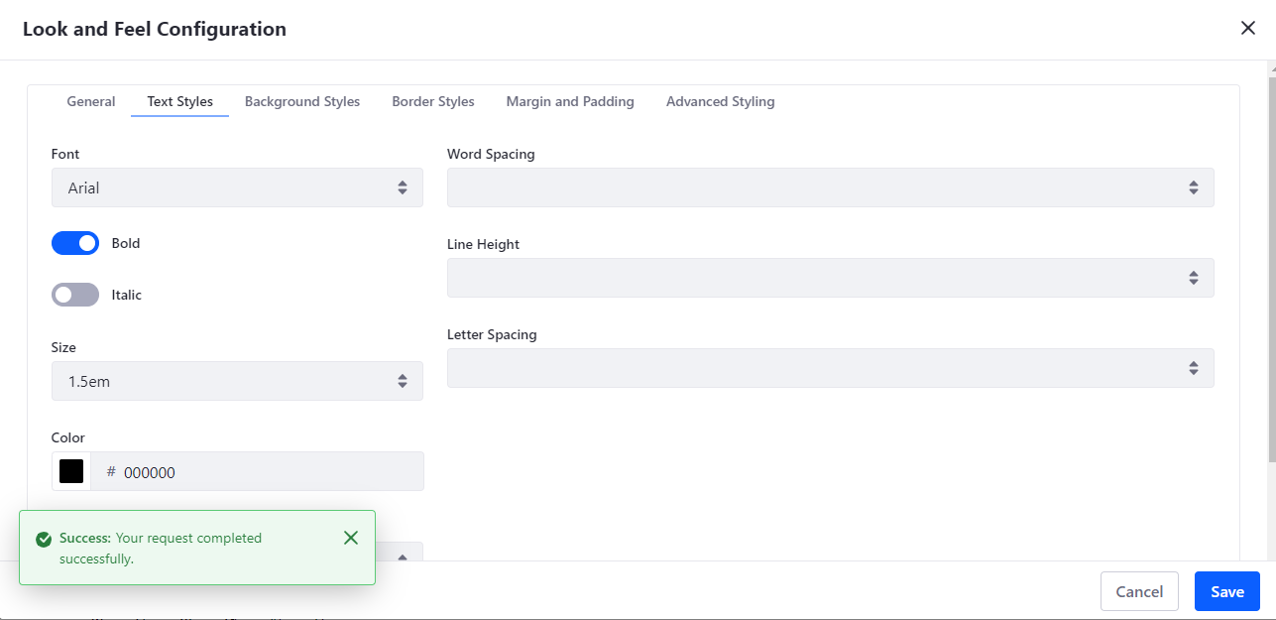

**Home page now**